**Introduction**

This report illustrates the analysis from given datasets, “Movies.csv” , “Gross.csv” and offers valuable insights about film industry to assist producer to make informed decisions to create profitable movies. Our objective is to reveal trends and patterns of various movie genres and focussing on financial performance over a period, all this while considering the audience ratings.

The analysis will be based on given historical data.

**Data Overview**

Summary of the movie dataset:

* Number of records - 23959
* Data structure (columns) – 47
* Data cleaning and preprocessing step – Changed values to -1 wherever, the column is either blank or stated NA.

**Target Audience**

Producer - This report analyses the key considerations for producers interested in investing in film production while aiming to predict customer preferences and maximize profitability. The film industry is dynamic and highly competitive, making informed investment decisions and predicting audience tastes crucial for success.

**Analysis**

Showcasing list of movie genres which have high gross margins.

In the provided chart, the Y-axis illustrates the funds (in dollars) invested by producers in various film genres and the resulting profits, and X-axis states the genres of the movie. Upon closer examination of the graph:

* The average budget allocated to documentary films is less than $1,50,000 while producers typically received profits nearing $2,00,00,000, surpassing their initial investment. For new producers seeking profitable ventures in the film industry, documentaries offer an excellent starting point.
* Documentary films also serve as a recovery mechanism for producers facing losses in other genres.
* Notably, the Sci-Fi genre exhibits higher budgets; however, it generates significantly greater profits. Among all the genres, Sci-Fi movies stand out for their profitability, with profits often doubling the initial investment. Experienced producers may find Sci-Fi investments particularly appealing.
* Despite an average budget near $2,80,000,000, the average profit in Sci-Fi is twice the producer's investment, making it an attractive genre.

The top five genres where producers should consider investing are:

1. Fantasy
2. Sci-Fi
3. Documentary
4. Action
5. Family

On the other hand, the following three genres warrant careful consideration before investment:

1. Music
2. Western
3. Horror

Histogram Graph for

* Distribution of Rating

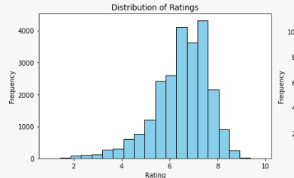

In the histogram chart presented above, it is evident that the distribution is skewed to the left. This dataset comprises a substantial collection of movies, totalling around 240,000 films. Notably, most viewers have assigned ratings falling within the 6 to 7.5-star range, with over 4,000 individuals offering ratings in the 7 to 7.5-star category.

Based on current average ratings analysis we can further analyse which genre produces highest ratings or which genre is more popular.

* Average rating and votes by Genre

In the above visualization we can see highest number of votes and rating is received by Adventure genre and the least number of votes and ratings is received by Horror genre. From this we can conclude that there is huge fan base for movies having adventure genre involved, and people tend to avoid watching horror movies.

* Box plot of Movie Ratings by Genre

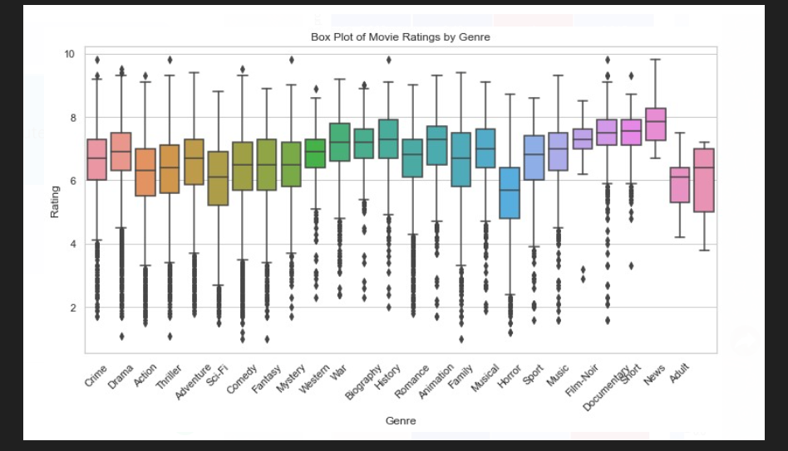

The boxplot depicted above displays customer ratings for movies across various genres. Notably, horror movies receive the lowest ratings, while genres such as documentary, short films, animation, adventure, and family consistently garner the highest ratings.

Based on this visualization, it is evident that horror movies are less popular among viewers, whereas genres like documentary, short films, animation, adventure, and family films tend to be more preferred by the audience.

* Distribution of Production

The charts above illustrate a left-skewed distribution, indicating that the number of movies has been on the rise each year. However, there was a minor dip in movie production between 1970 and 1980. Subsequently, production began to ascend steadily, with a notable and substantial increase in the number of movies between 1990 and 2000.

Why there was fluctuation between year 1970 – 1980?

Economic conditions can play a significant role in film production. The 1960s and 1970s saw economic challenges such as inflation, rising production costs, and economic recessions that affected the industry. Studios had to reduce their film output in response to economic pressures.

Top 3 highly correlation for Genre using Heatmap.

The presented heatmaps exhibit a strong positive correlation between the variable’s 'budget' and 'gross' of genres, implying that as the budget increases, there is a corresponding increase in the gross revenue. This correlation suggests a direct and significant relationship, indicating that higher budgets tend to result in higher gross earnings.

* Correlation for Mystery

* Correlation for Drama

**Conclusion** –

This report analyses the film industry using historical data from "Movies.csv" and "Gross.csv" to guide film producers in making informed, profitable decisions. Key findings include:

* High-grossing genres: Documentary films offer substantial profits with low budgets, while Sci-Fi movies generate significant returns, making them attractive options for producers.
* Audience preferences: Adventure genres receive the most ratings and votes, while Horror genres are less favoured.
* Popular genres: Adventure, documentary, short films, animation, and family consistently receive high ratings, while horror movies consistently get lower ratings.
* Production trends: Movie production has steadily increased, with a minor dip in the 1970s due to economic challenges.
* Correlation analysis: Higher budgets are strongly correlated with higher gross earnings.

In summary, producers should consider documentary and Sci-Fi genres for profitability, acknowledge the popularity of adventure genres, and exercise caution when investing in music, western, and horror genres. Economic factors can influence production trends.

Top of Form